South East Technological University,

Waterford


Semester 1: Project Analysis and Design
Creating a Tool-Kit for a Musician to Produce Promotional Materials

_________________________________________

Author: Supervisor:

Jake Dunphy O’Leary Brenda O’Neill

Student Number:

20101923

Course:

Creative Computing

Tuesday, November 18, 2025

Image of you here

“Quote you like here…”

Where the quote is from. (Citation to reference at back of report)

South East Technological University, Waterford

Abstract

School of Science and Computing

Department of Computing and Mathematics

Course Creative Computing

for 4th year Semester 1 project.

Creating a Tool-Kit to a Musician to Create Promotional Materials

By

Jake Dunphy O’Leary

Keyword Names:………………………………………

Declaration of Authorship

I, Jake Dunphy O’Leary, declare that this report titled, “Creating a Tool-Kit to a Musician to Create Promotional Materials” and the work presented in it are my own. I confirm that:

This work was done wholly or mainly while in candidature for an undergraduate degree at this University.

Where any part of this report has previously been submitted for a degree or any other qualification at this University or any other institution, this has been clearly stated.

Where I have quoted from the work of others, the source is always given. With the exception of such quotations, this report is entirely my own work.

I have acknowledged all main sources of help.

Where the report is based on work done by myself jointly with others, I have made clear exactly what was done by others and what I have contributed myself.

If AI was used, I have made clear why and how AI was used.

Signed:

------------------------------------------------------------------------------------------

Date:
---------------------------------------------------------------------------------------------

List of Figures……….

List of Tables………

List of Abbreviations……….

Acknowledgements

Table of Contents
Abstract III
Declaration of Authorship IV
List of Figures………. V
List of Tables……… VI
List of Abbreviations………. VII
Acknowledgements VIII
Chapter 1: Introduction 1
Chapter 2: Project 2
Description 2
Inspiration 2
Scope 2
Target Audience 2
User Stories 2
Chapter 3: Feasibility 3
Market 3
Commercial 3
Unique Selling Points 3
Technical Feasibility 3
Risk Assessment 3
Chapter 4: Technologies 4
Hardware 4
Software 4
Methodology - Agile SCRUM??????? 4
Chapter 5: System Architecture 4
Systems Overview Diagram 5
User States 5
Flow Chart 5
Sequence Diagram: User Authentication 5
Architecture Design 5
Component Design. 5
Use of API(s) 5
Chapter 6: Data Design (This could be changed for design elements that you are using) 5
Data Type Tables 6
Class Diagram and Entity Relationship 6
Object Schemas 6
Chapter 7: UX Design 7
Notification Screen & Product Screen 7
Product Review and Price Comparison Screens 7
Sign-in Screens 7
Navbar - Drop Down Menu and Profile Settings 7
Voucher and QR Code Screens 7
Mock-ups 7
Chapter 8: Planning Schedule 8
Design and Development Schedule 8
References 9
Appendices 10
Anything detailed that you reference in the body of the report but provide the details for here. 10
User Manual? 10
Notes taken when setting up the software…etc…. 10

Chapter 1: Introduction

Design software, much like anything else in the world, comes in many different forms and styles. Often times, people flock to the most popular or well-regarded software for their needs, but this does not always mean they are the best option. In a world of ever-advancing technology, it is more important than ever to consider all options, and analyse what makes a software “industry standard”. Doing so may help in seeing why the trendy software is as popular as it is, or it may be found that the software does not gel.
This project exists as both as a baseline and as a demonstration. It shows creatives that, while the first hurdle may be the most daunting, it is certainly not impossible to cross. Whether it is budget constraints, a lack of powerful hardware, or simply a lack of technical knowledge, there are options for software that to suit diverse needs.
The goal for this project is that it can be used as a guide to those looking to dip their toes into digital creation, either as a hobby or even as a potential career option.

Chapter 2: Project

Description

This project entails the creation of various promotional materials for a musician to use to promote their musical projects. This includes:
- An album box art (front, back and sides)
- A digital cover for streaming services
- An artist logo and banner (for use on social media and streaming sites)
- A CD design
- A promotional poster
- A track list poster
- Merchandise designs (t-shirts, hoodies, stickers, etc.)
The following software that this document aims to look at are:
Program Table | Industry Standard | Proprietary | Open Source
Photo Editing | Photoshop | Affinity Photo | GIMP
Vector Graphics | Illustrator | Affinity Designer | Inkscape
3D Modelling/Rendering | Maya | ZBrush | Blender
Video Editing | Premiere Pro | Magix Vegas | Kdenlive
Digital Motion Graphics | After Effects | DaVinci Resolve | Friction

Inspiration

The inspiration of this project comes from various musicians and the different design languages they use to express their craft. Visual design has an inherent relationship with music and this project aims to show and detail that connection and make it easier for the reader to develop their own design language for their music projects.

Scope

The scope is to utilise design software that covers different segments of digital creation (Video Editing, Photo Editing, Vector Graphics, etc.), sorted by release types (Industry Standard/ Proprietary/Open Source). These programs will then be used to create design and promotional material for a music album and relevant materials (merchandise, posters, etc.). The process of creating these materials will be comprehensively documented using these programs, based on experience and knowledge gained whilst using them.

Target Audience

Creatives struggle to get their feet off the ground when it comes to making sleek and professional materials with their own hands. This document aims to give a baseline for creatives to work with. By the end of this document, the reader leaves with a good idea of how to make their start in digital creation.

User Stories

Chapter 3: Feasibility

Market

Commercial

Unique Selling Points

Technical Feasibility

This project as a whole is achievable with some minor obstacles. The first of which being that a computer of some kind is required to use all of the programs that this document details. Some programs may have alternatives for mobile devices, but most do not and even the ones that do likely lack full functionality.
While this project details free and open-source programs, there are also paid software listed here. These programs may have free trials or ways of trying them without paying, but their full functionality will be behind a paywall.
Having an interest in digital creation is important. This project does not require the reader to have a vast and detailed knowledge of design and computing, but it is recommended to make this document easier to follow. A stable internet connection is also highly recommended so the user can access educational resources and keep their programs up-to-date.

Risk Assessment
This project bears some risks that are important to keep in mind. This project is not dangerous in any way, but working with digital data can be volatile due to the inherent nature of computers and data.
Keeping backups of all projects and exports is extremely important. Losing the data for a project can be a massive setback, and no easy ways to recover old projects can be detrimental. Having an extra hard drive or cloud storage to make backups on regularly is recommended.
This project also comes with a potential major budgetary risk, which involves the replacement or purchasing of a new computer, if necessary. Computers can break for any number of reasons, and your primary device failing while completing the project is an unlikely but completely possible risk.
Another major risk with creative works is copyright infringement. This document and project strongly recommend the reader to do heavy research on the terms and conditions of any pre-made assets used, and to understand the conditions set out by the creators of the programs that this document discusses. This is an especially important risk to take into account when it comes to Artificial Intelligence (AI), which this document strongly discourages the incorrect usage of.

Chapter 4: Technologies

Hardware
For this project, I will be using two different devices. A higher budget desktop computer, and a lower budget Office Laptop.
Laptop Specifications:
Make/Model: Avita Liber V
Screen Size: 14 Inches, 1920x1080 HD Display
Ram: 8 GB DDR4
CPU: AMD Ryzen 5 3500U
GPU: Radeon Vega 8 Graphics
Storage: 250GB SSD
Operating System: Windows 10 LTSC
Desktop Specifications:
Motherboard: MSI PRO H610M-E DDR4 (MS-7D48) 2.0
RAM: 16GB DDR4
CPU: Intel Core i5 12400F
GPU: NVIDIA RTX 3060 12GB
Storage: 1TB SSD
Operating System: Windows 10 LTSC

Software

Open Source:
Open source, in relation to software, refers to software where the owner and creator allows others to freely use, inspect, and modify its source code. This encourages open collaboration and community between both users and developers. Open-source software is typically free, but this is not guaranteed. Open-source software is typically created for a multitude of reasons. This includes:
- Fulfilling an untapped niche.
- To provide a lower cost alternative to an existing proprietary program.
- For a developer to practice development with a low-stakes project.
There are many other reasons for Open-source software to be created, but these are some of the more common origins. Not for profit.
Open-source does not necessarily mean it is made independently or without a team structure. Two examples of project team structures are detailed by Ben Balter.
Balter describes the Cathedral and Bazaar people management styles.
The Cathedral style works top-down using a focused vision and goals, led by a manager. It provides clarity and a sense of stability, but can feel rigid and like a hierarchy. Poor management is felt deeply in this style.
The Bazaar style works more broadly and without specific, detailed goals. The manager acts like a guide or a coach for the team, rather than a leader. This style promotes innovation and openness, but can lead to confusion and aimlessness if poorly managed.

Proprietary:

Proprietary software is software that is only available to its creators, typically a company, that is the software’s sole developer and distributor. Proprietary software can also be described as “for profit” software, existing with the intention of selling to a large consumer base.
Proprietary software often takes less risks or experimentation compared to open-source software, and have tightly held licenses and source code that are rarely, if ever, released to the public willingly. Software is made proprietary for various reasons, such as:
- Preventing competing companies from using their source code as a baseline.
- Preventing users from freely modifying and changing code, therefore requiring reliance on the owners.
- Allowing for tightly locked license distribution, making piracy more difficult.
- Making security updates more secure due to a lack of freely available code.
Proprietary software is often developed by much bigger and more experienced teams, with a focused vision in mind. This leads proprietary software to come across more professional and solid compared to open-source software. This comes at a literal cost, as well as the cost of transparency and communal development. Typically, commercial.
A good example of commercial design products is the Adobe suite. Adobe creates and manages a large variety of design programs, some of which this document looks at in more detail.
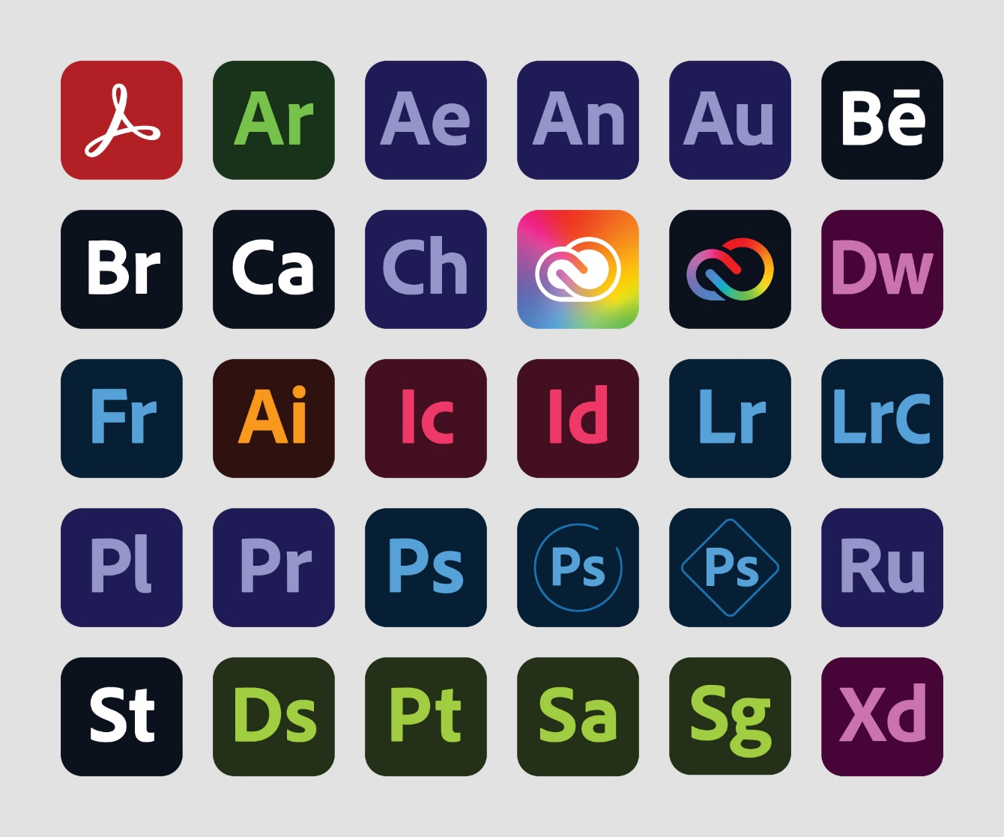
Figure 1 - Adobe Product Logos

Methodology

Choice of Methodology
This document does not use one singular methodology throughout, such as Agile or Waterfall. The reason for this is that design and artistic projects are not as rigid and measurable as a project such as software development. Because of this, each major creation aspect this document covers will use its own methodology, decided on through analysing the most common method used by professionals.

Graphic Design
This document lays out a 6-step process for the Graphic Design aspect. This methodology is documented by Ihor Kirpichnikov, and Jessica Barker of Brafton. The steps are as follows:

Design Brief
This step is where the aims of the design are pre-defined. This can involve detailing a design language, what style to achieve, what formats and canvas sizes will be used, what the design is for, etc.
This step is where the basis of the project is laid out.
For example, if designing a CD Cover, you need to consider how large a CD is, how to print the cover onto a real CD, and what style the CD will have.

Research Phase
This step involves looking at other designs and research good and bad habits in graphic design. The point of this step is to get a clearer vision of what to achieve with the design, and how to make sure it looks professional and clean.
Since this project involves creating promotional materials, look at other album covers, physical album boxes, various pieces of merchandise, song visualisers, etc. This can allow the designer to see what they do and don’t like to have a better understanding for future projects.

Concepts
This step involves brainstorming designs. This includes inspirations, colours, emotions, moods, images, layouts, etc.
The ideas and concepts thought up in this step become the basis for the full design. This step is also why it’s best to do the graphic design first, as it will influence the design theming for the rest of the project.
It’s here that it’s best to have a description of what is it being created, and what the design is meant to invoke in the viewer.

Concept Development
This step is where you experiment and plot out the ideas initialised in the previous step. This includes making mock-ups, experimenting with colour palettes, testing fonts, etc.
For example, on a CD cover, decide if the text should go on the sides or on the top or bottom. Look at the colour wheel and what palettes mix well together. This is also a good place to practice using the chosen design programs.

Concept Feedback
This step involves showing the conceptualised designs to others to get outside opinions and feedback. This can be done formally through surveys, or informally through word of mouth. This feedback can then be used in the final step.
This can be done through A-B Testing (showing two different designs and asking others to choose which they prefer) or through simple surveys.

Polishing
This step is simple. Take the feedback and opinions received in the previous step, and use them to polish and perfect the final designs. These last two steps can be repeated until satisfied with the final product. This step may take the longest time depending the vision and scope of the project.

Chapter 5: System Architecture

Systems Overview Diagram

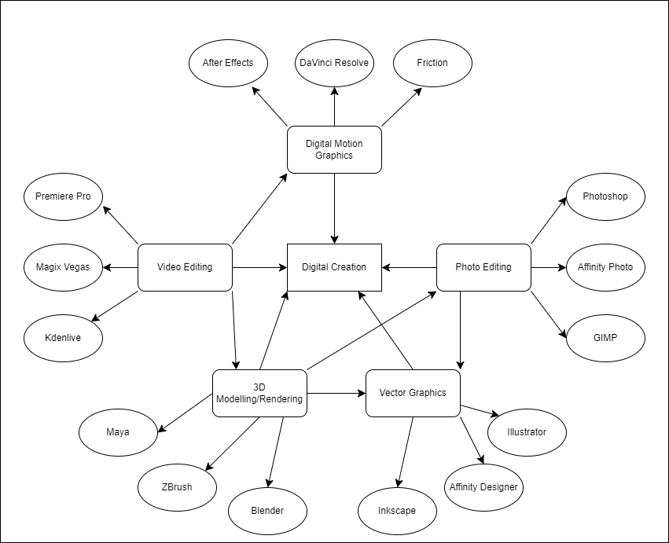

User States

Flow Chart

Sequence Diagram: User Authentication

Architecture Design

Component Design.

Use of API(s)

Chapter 6: Data Design (This could be changed for design elements that you are using)

Data Type Tables

Class Diagram and Entity Relationship

Object Schemas

Chapter 7: UX Design

Notification Screen & Product Screen

Product Review and Price Comparison Screens

Sign-in Screens

Navbar - Drop Down Menu and Profile Settings

Voucher and QR Code Screens

Mock-ups

Chapter 8: Planning Schedule

Design and Development Schedule

Break down next semester into 12 weeks. Your methodology should inform this plan i.e. if Agile then you need to show sprints,feedback loops etc….
You can use a Gantt chart or Excel spreadsheet – think of this being the schedule that you print out and pin at your work station next semester.
Also what tools are you using for planning, Trello or some such….????

References

Blake, H. (2025). Cost-Benefit Analysis Proprietary Licensing Vs. Open Source Economics. [online] ResearchGate. Available at: https://www.researchgate.net/publication/392557896_Cost-Benefit_Analysis_Proprietary_Licensing_Vs_Open_Source_Economics. [Accessed 18th Nov 2025]

Hoffmann, M., Nagle, F. and Zhou, Y. (2024). The Value of Open Source Software. SSRN Electronic Journal. [online] https://doi.org/10.2139/ssrn.4693148. [Accessed 18th Nov 2025]

University, D. of I.T.H., Ave, 400 S.O., South Orange, N. 07079 and (973) 275-2222 (n.d.). Adobe Creative Campus - Seton Hall University. [online] www.shu.edu. Available at: https://www.shu.edu/technology/adobe.html. [Accessed 18th Nov 2025]
‌
Sennett, R. (2008). The Craftsman. Penguin UK.
‌
Balter, B. (2023). Cathedral vs Bazaar People Management. [online] Ben Balter. Available at: https://ben.balter.com/2023/12/08/cathedral-bazaar-management/ [Accessed 3 Nov. 2025].

Appendices

Anything detailed that you reference in the body of the report but provide the details for here.

User Manual?

Notes taken when setting up the software…etc….

